DPRC Connectome Pipeline

This pipeline is made to create a ‘structural connectome’ which will represent the connection between the white matter fibres to the grey matter regions. This will demonstrate the structural connectivity between the regions of the brain. Preprocessing is done via fmriprep (This should be the first step which is done for this Connectome pipeline). Anatomically constrained tractography (ACT) and Spherical-deconvolution Informed Filtering (SIFT) will be utilised for generating the tracts. Script and files needed can be downloaded from here: <https://github.com/Ltah72/DPRC-analysis>.

Connectomes are very computationally expensive, as we are having to generate tractography files for **each participant**. It is estimated to take ~17 hours per participant, which means that with 200 participants, it would take around 3400 hours or close to 5 months to run all participants in the dataset. It would be good to invest in high computational power, such as clusters like the New Zealand eScience Infrastructure (NeSI).

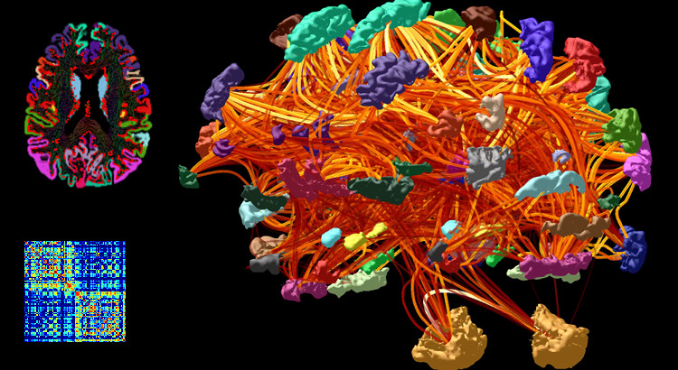

MRtrix3 manual: <https://mrtrix.readthedocs.io/en/latest/quantitative_structural_connectivity/structural_connectome.html>

Here are some other, good online free manuals on creating a connectome using MRtrix3:

B.A.T.M.A.N.: <https://osf.io/fkyht/>

Andrew Jahn’s brain book: <https://andysbrainbook.readthedocs.io/en/latest/MRtrix/MRtrix_Introduction.html>

Steps:

1. Preprocess anatomical images (T1w and T2 FLAIR images)
   1. Gibbs ringing correction (mrdegibbs)
   2. Run fmriprep to preprocess anat + func images
2. Create a 5tt image for ACT
   1. Co-registration t1w and t2 FLAIR to dwi image
   2. Generate a ‘4tt image’
   3. Edit in a pathological image to create a ‘5ttimage’
   4. Create a ‘seed’ boundary between the white and grey matter for streamline generation
3. Create streamlines for tractography with ACT
4. Refine streamlines with SIFT
5. Create the connectome

Option 1: Create an 84 x 84 connectome (simple)

* + 1. Convert labels to MRtrix format
    2. Co-register the parcellation to the grey matter boundary
    3. Create the whole-brain connectome

Option 2: Use HCP MMP 1.0 atlas – 379 x 379 connectome

1. Map annotation file of HCP MMP 1.0 atlas from fsaverage to your subject
2. Map HCP MMP annotations onto volumetric image and add subcortical segmentation
3. Replace random integers of hcpmmp1 file with integers that start at and increase by 1
4. Register the ordered atlas-based volumetric parcellation to diffusion space
5. Create the whole-brain connectome
6. Select a specific tract between regions from the connectome
7. Perform group-wise statistics of the connectome using non-parametric permutation testing
   1. On whole-brain connectome (all nodes)
   2. On nodes / connections of interest
8. Options for connectome visualisation
   1. Make the connectome appear more ‘anatomical’
   2. Check over connectome files
9. **Preprocess anatomical images (T1w and T2 FLAIR images)**
10. **Gibbs ringing correction (mrdegibbs)**

Corrections for various artefacts, such as table vibration, radio-frequency-based distortions, and incorrect magnetic field gradient calibration, which can significantly degrade diffusion data. The Gibbs ringing artefact appears in k-space truncation along finite image sampling, and it can be suppressed by post hoc methods.

This method is based on local sub-voxel shifts. The strength of ringing (caused by truncation of Fourier transform space) is dependent on the location of the edge relative to the sampling grid. Method works by finding optimal sub-voxel shift in the neighborhood of shard edges. The Gibbs ringing correction should be done before the other preprocessing corrections, and is ideally one of the first corrections that is done. Gibbs ringing correction has been included in the RunFmriprep.m script.

Command: mrdegibbs

For DPRC MPRAGE (t1w) data, the slices were acquired in the **___ plane** or the **sagittal direction**, and so you can add on the option of -axes ____.

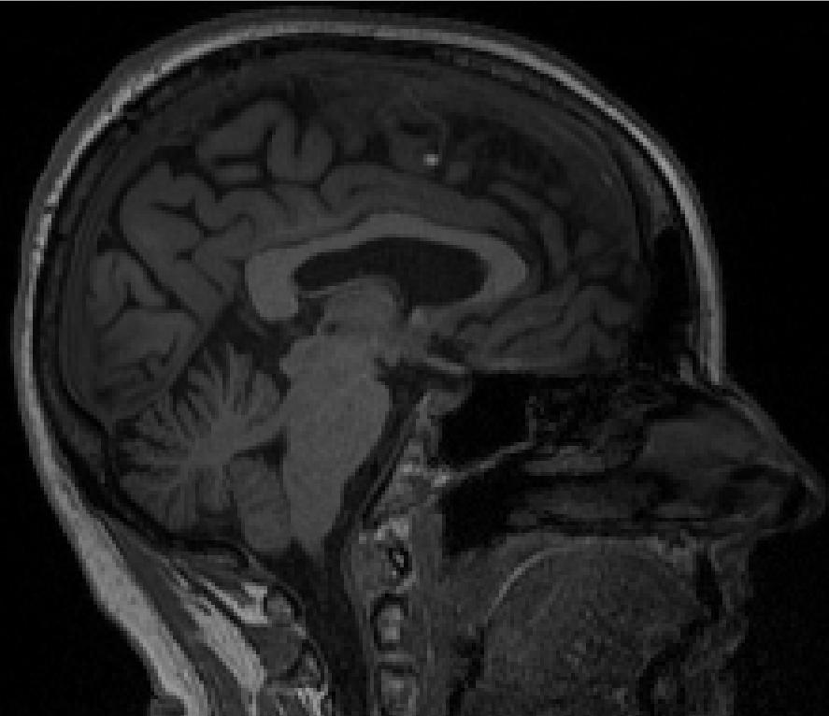 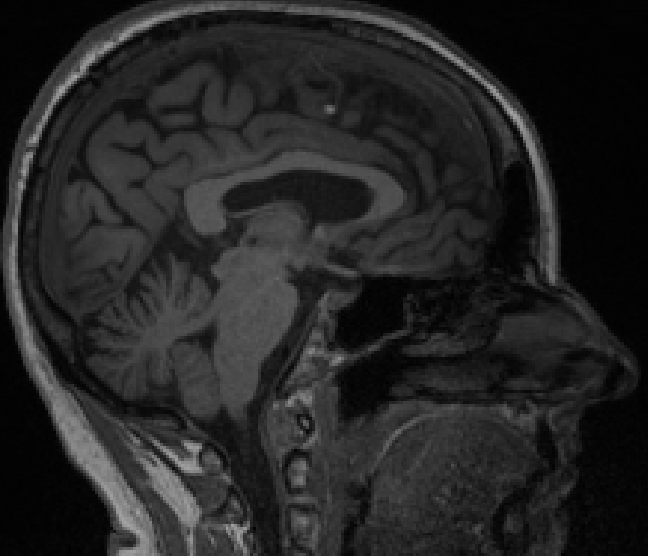

T1w raw T1w, Gibbs ringing corrected

%Sample output: gsub-ADPRC0001F0_T1w.nii

Elapsed time: 20 sec

*Kellner et al., (2016). Gibbs-ringing artefact removal based on local subvoxel shifts*

1. **Run fmriprep to preprocess anat + func images**

Running fmriprep (RunFmriprep.m) will complete the following corrections on the anatomical (T1w, T2 blade, T2 FLAIR) images and the functional (BOLD) images. Version 20.2.1. 1

Prior to running fmriprep, you need to make sure that .json files (in the /fmap files) are in the correct format (ModifyFilesForFmriprep.m).

Anat:

* + Bias field correction (N4 algorithm, ANTs)

Bias field correction done on the t1w prior to inputting them into 5ttgen. Bias field correction is done by brain extraction (BET) and bias field correction (ANTs). Note that bias field correction will still need to be done on the t2 FLAIR image.

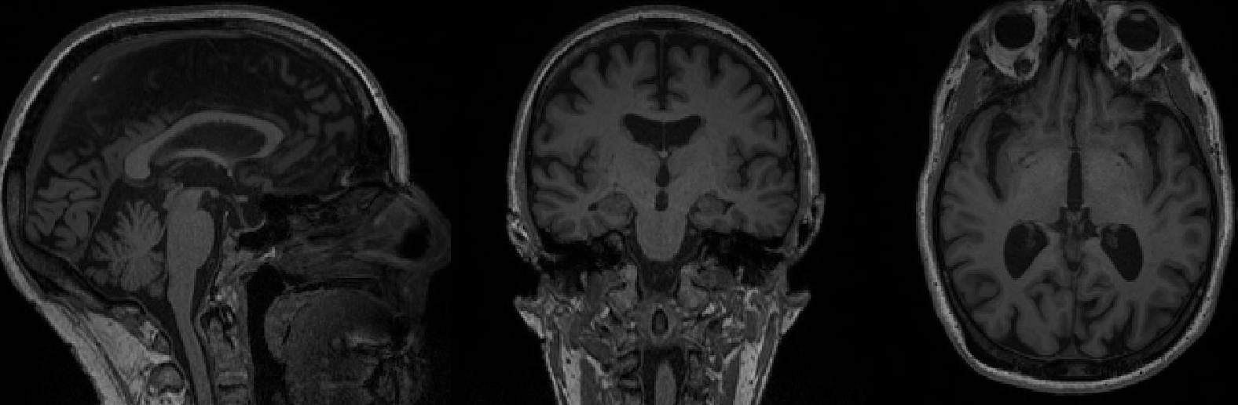

T1w raw

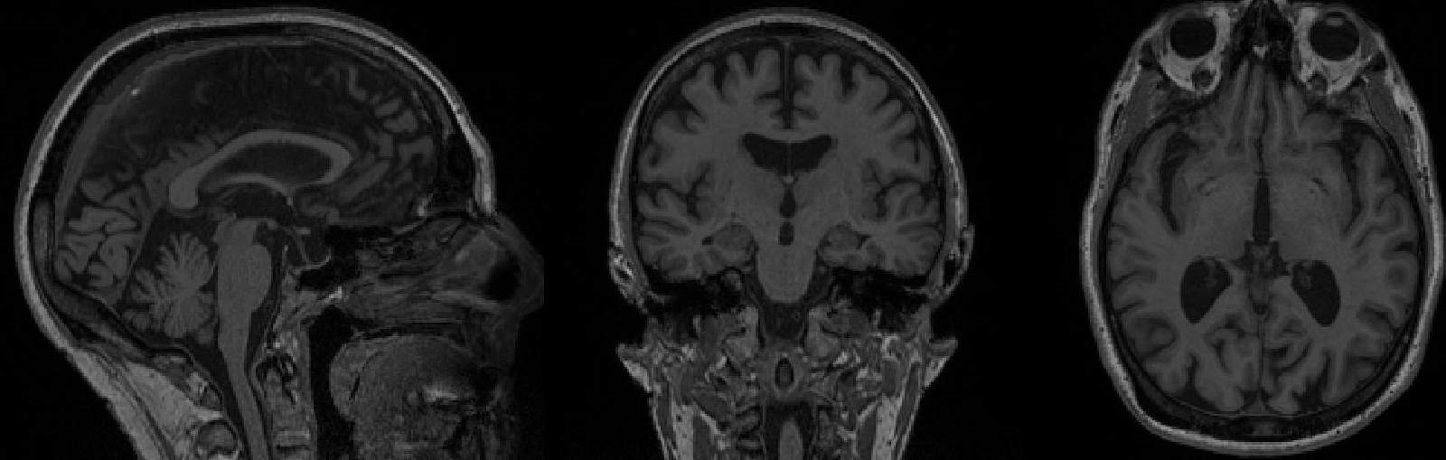

T1w, bias field corrected (you can see this better if you overlay on *fsleyes*).

Run bias field correction, using ANTs N4 algorithm: <https://community.mrtrix.org/t/t1-like-contrast-from-dwi-data/2782>

<https://community.mrtrix.org/t/preprocessing-questions/995/2>

* + Skull-stripped (antsBrainExtraction.sh, ANTs)
  + Brain surface reconstruction (recon-all, FreeSurfer)

Now, we will parcellate the brain using the atlas on FreeSurfer, which assigns each voxel in the brain to a specific ROI. To do this, you will need to run each subject’s anatomical images though the FreeSurfer command, recon-all, which can take up to a few hours per participant. The participants T1w is adequate for this step, but you can improve parcellation with adding a T2 or FLAIR image to the command.

This step will can take up to a few hours per participant, and may take days/weeks to run this command on a larger dataset. Fortunately, with the DPRC dataset, much of this data has already been processed with the open-source **fmriprep pipeline** (<https://fmriprep.org/en/stable/>), and so we will actually be getting the preprocessed and segmented data from there (so no need to run the recon-all command if you will be doing this instead).

If you do not have output ready from others, you can also speed up the process by using parallel processing. FreeSurfer has the ability to add in the -parallel flag, which will mainly increase the CPU allocation towards mri_em_register and mri_ca_register in the recon-all command. By default, it instructs to use 4 CPUs, but you can change this by using the -openmp <num> flag after the -parallel flag, with num being the number of CPUs that you wish to allocate for this.

<https://surfer.nmr.mgh.harvard.edu/fswiki/ReleaseNotes> 2

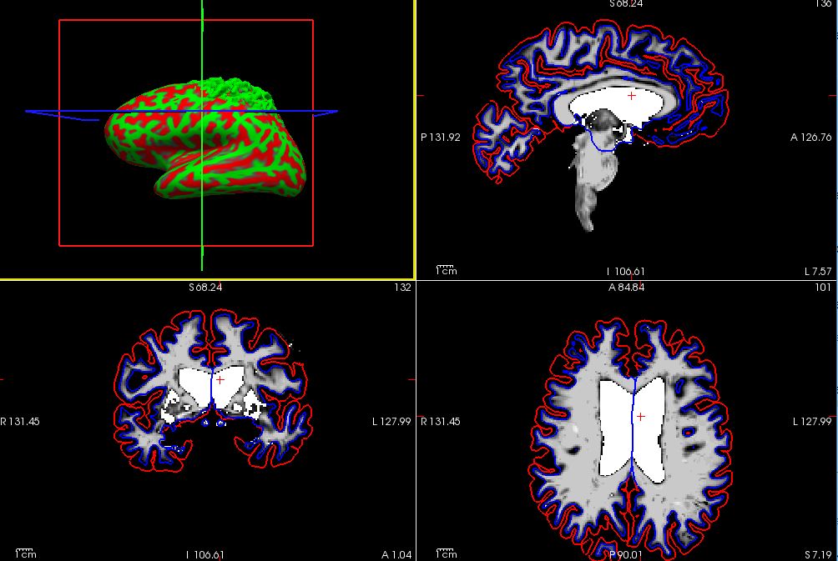

White matter volume segmentation (*wm.mgz*) shown in Freeview (FreeSurfer gui). Red is the pial outline and blue is the white matter outline. Inflation of the brain has been applied on the cortical surface (top left window).

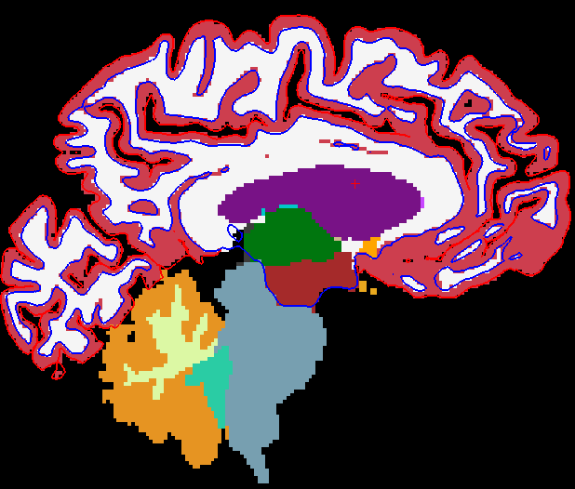 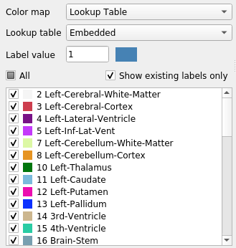

Segmented regions of the brain (*aseg.mgz*) as parcellated by FreeSurfer. 3

Elapsed time: 4 hours and 30 min for recon-all (with parallel flag option; T1w + FLAIR)

10 hours and 42 min (with only T1w)

17 hours and 26 min (with both T1w + FLAIR)

(per participant)

<https://surfer.nmr.mgh.harvard.edu/fswiki/recon-all>

* + Brain mask estimation (ANTs + FreeSurfer)
  + Spatial normalization (antsRegistration, ANTs)
  + Brain tissue segmentation (FAST, FSL)

Func:

* + Slice time correction (3dtshift, AFNI)
  + Motion correction (mcflirt, FSL)
  + Coregistration to T1w, 6 dof (bbregister, FreeSurfer)
  + Motion correcting transformations (antsApplyTransforms, ANTs)
  + ICA-AROMA denoising on single subjects (MELODIC, FSL)
    1. --use-aroma flag in fmriprep 4 , 5

Elapsed time: 7 hours and 41 min (with all corrections above applied)*

~9 hours with ICA-AROMA implemented

*Esteban, O., Markiewicz, C. J., Blair, R. W., Moodie, C. A., Isik, A. I., Erramuzpe, A., … Gorgolewski, K. J. (2019). fMRIPrep: a robust preprocessing pipeline for functional MRI.*

*note that you can apply FreeSurfer’s recon-all separately (and ‘parallely’) with fmriprep, and just move the file folders around to make the processing faster and more efficient, which is what I did. This might be good to do because fmriprep seem to only maximally use up to 8 CPUs for processing, while with FreeSurfer, this can be modified to as many CPUs as you would want.

1. **Create a 5TT image for ACT**

We will create a 5 Tissue Type (5TT) image to use for the Anatomically-Constrained Tractography (ACT). By combining the t1w and t2 FLAIR images for brain segmentation, this will help to make anatomically and biologically plausible segmentations when generating the tractography. Four main steps (a, b, c, d) are carried out in order to do this. See the MRtrix ACT manual for more information: <https://mrtrix.readthedocs.io/en/latest/quantitative_structural_connectivity/act.html>

1. **Co-registration of t1w + t2 FLAIR with dwi image**

Linear registration with 6 degrees of freedom (dof) are used. Do this registration with both the t1w and t2 FLAIR images to the dwi image (first b0 vol in dwi sequence - captured as the ‘bestb0’ from the previous script).

Command: flirt (fsl)

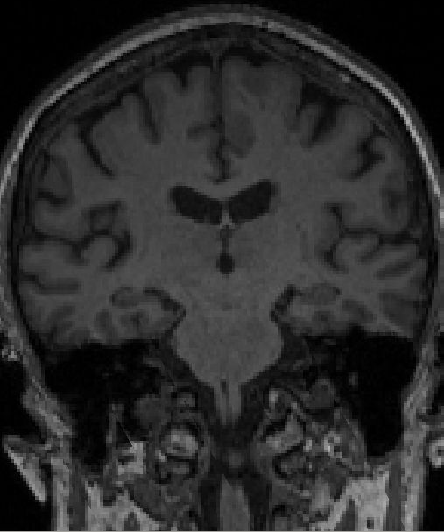 **+** 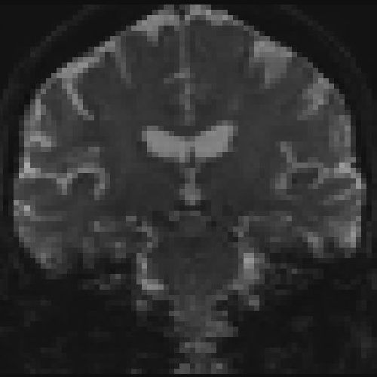

T1w dwi (b0)

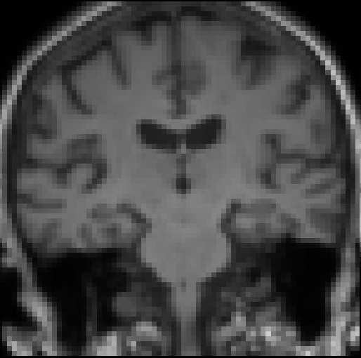

Co-registered (t1_flirt)

Once you have applied co-registration using FLIRT, you need to create linear transform matrices to apply to the images. This is because by default, FLIRT applies a direct *resampling* of the input image to match the target image, which is unnecessary. It is better to have flirt provide the calculated transformation matrix, then *apply* that linear transformation to the T1 image (either using flirt again, or combination of transformconvert and mrtransform), such that the image header transformation is altered but the image grid / intensities are not.

Command: transformconvert

mrtransform

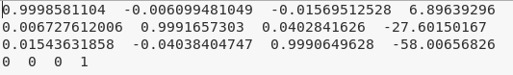

*transform_flirt_t12dwi.mat*

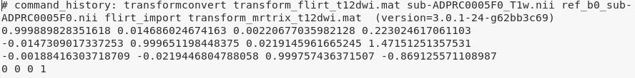

*transform_mrtrix_t12dwi.mat*

See posts on mrtrix community forum for more info: <https://community.mrtrix.org/t/5ttgen-error/1138>; <https://community.mrtrix.org/t/5ttgen-waiitng-for-creation-of-new-file/1044/2>

In addition, the provided T2 FLAIR image must be resampled to match the T1 image: <https://community.mrtrix.org/t/5ttgen-provided-t2-image-does-not-match-input-t1-image/1204>

Elapsed time: 59 sec

1. **Generate a ‘Five-Tissue-Type’ (but with 4 tissue types for now) image**

The 5 tissues include: cortical gm, subcortical gm, wm, csf, pathological tissue(*). Inputs to the 5ttgen include the t1w, t2 FLAIR image, the brain mask (generated from the preprocessing script), and the preprocessed/segmented t2 FLAIR (see below) as the pathological tissue. The 5ttgen script using the fsl algorithm interfaces with FSL to generate the necessary image data from the raw T1 and T2 FLAIR image, using BET, FAST and FIRST. 6

Command: 5ttgen -fsl

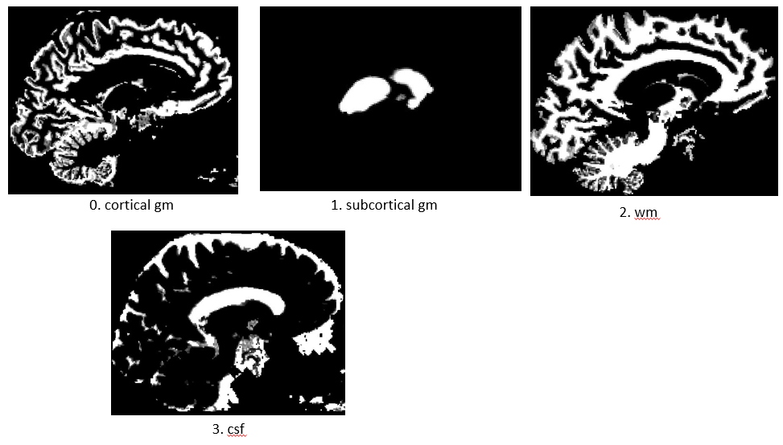

1. Cortical grey matter
2. Sub-cortical grey matter
3. White matter
4. CSF
5. Pathological tissue*

The highlighted white areas represent the specific tissue type.

%Sample output: 4ttimage_sub-ADPRC0001F0.mif

Elapsed time: 12 min 52 sec

1. **Edit in a pathological image to create a 5ttimage**

*To add in the pathological tissue (in this case, with the white matter hyperintensities (WMHs) using the t2 FLAIR which is preprocessed and segmented with the lesions as a mask), you will need to edit and add in the image to the 5tt image. Using the toolbox Lesion Segmentation Tool (LST) (Schmidt & Wink, 2019) under SPM, the lesion prediction algorithm (LPA) (Schmidt, 2016) has done the preprocessing and segmentation of the WMHs. LPA is an automatic segmentation program which does not require any parameters set by the user and only requires the T2 FLAIR image as its input. To do this, I have utilised the commandline option from LST (RunLST_LPA.m) to create the WMH masks for all participants. Match the pathological image to the 4ttimage on the same space (use mrtransform).

Command: RunLST_LPA.m

5ttedit

mrtransform

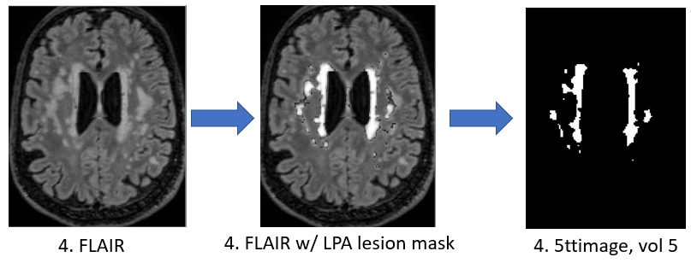

More information about dealing with WMHs from the MRtrix forum: <https://community.mrtrix.org/t/5ttgen-recommended-approach-to-dealing-with-white-matter-hyperintensities-wmhs-for-act/3753/3>

Maybe better to use 5ttgen -hsvs algorithm instead – combination of fsl and FreeSurfer tools. Hsvs = hybrid surface and volume segmentation.

<https://community.mrtrix.org/t/5ttgen-hsvs-template-option/3593/7>

%Sample output: 5ttimage_sub-ADPRC0001F0.mif

Elapsed time: 2 sec

You can quickly and easily evaluate each 5tt image by running MRtrix’s 5ttcheck command; this will thoroughly check that the images conform to the expected ACT five-tissue-type (5TT) format. My script does this with the **FiveTTImageCheck.m** function, and the output is a text file (5ttImageCheck.txt), which displays the status of the 5tt image for all participants.

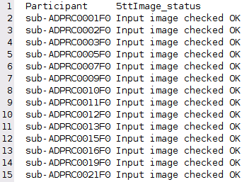

Elapsed time: 15 sec for 36 participants

1. **Create a ‘seed’ boundary between the white and grey matter for streamline generation**

This will create a mask image for the boundary separating the grey from the white matter, which we will be appropriate for seeding streamlines for tckgen.

Command: 5ttgmwmi

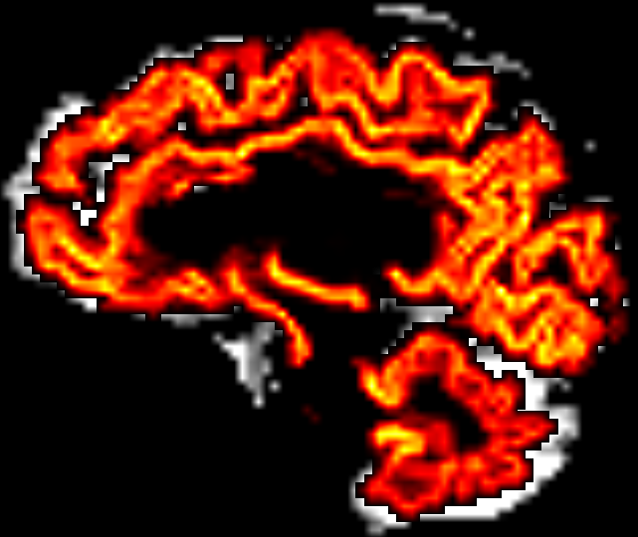

The ‘seed boundary’ mask, separating the grey from the white matter, overlayed on top of the 5tt image, with the grey matter segmentation (vol 0).

Elapsed time: 1 sec

%Sample output: gmwmSeed_mask_sub-ADPRC0001F0.mif

1. **Generate streamlines for tractography with ACT**
2. Create the streamlines with all of the created boundaries and images which were done in the previous steps. Use the -act and -seed_gmwmi options. The anatomically constrained tractography (ACT) option to input in the different tissue types of the brain to generate more biological plausible orientations (by using the 5tt image that we generated in the previous steps). It is also recommended to NOT provide a brain mask if you are using the 5TT image as input for ACT. The -backtrack option will resample rejected streamlines from a defined number of steps back.

Command: tckgen -act -backtrack -seed_gmwmi

Some additional options are inputting the ‘seed boundary’ between grey matter and white matter image that we created in the previous step, and the -backtrack option, which indicates for the current streamline to go back and run the same streamline again if it terminates in a strange place (e.g. in the CSF).

Elapsed time: 2 hours and 22 min

%Sample output: tracks_10M_sub-ADPRC0001F0.tck

You won’t be able to see the .tck file if you generated a large amount of streamlines (e.g. 10 million). So, if you wanted to view them, make a smaller version.

Command: tckedit -number 200k

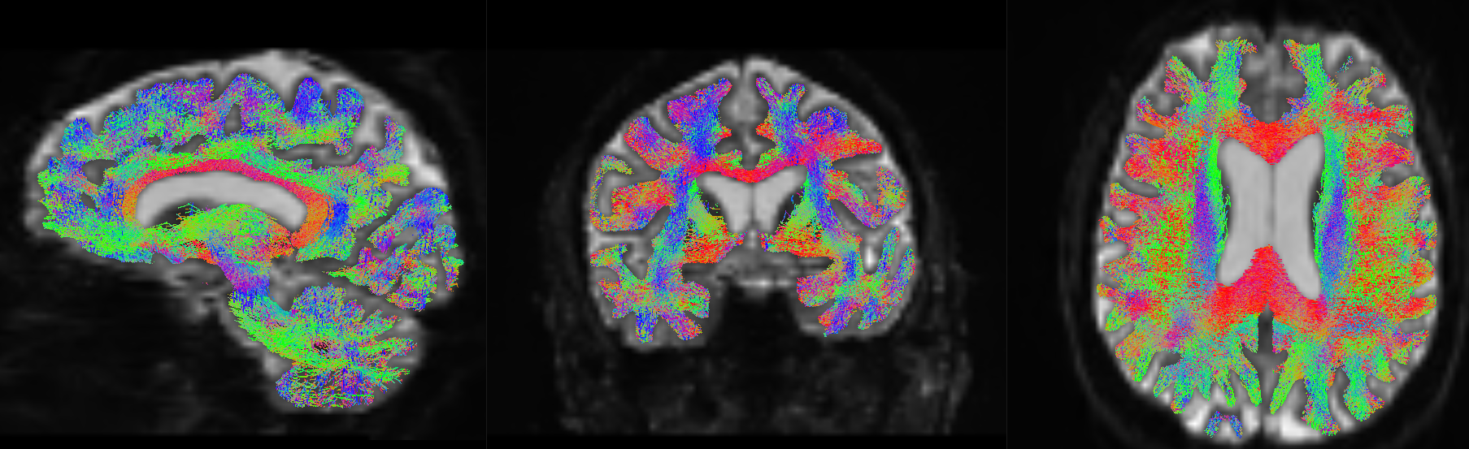

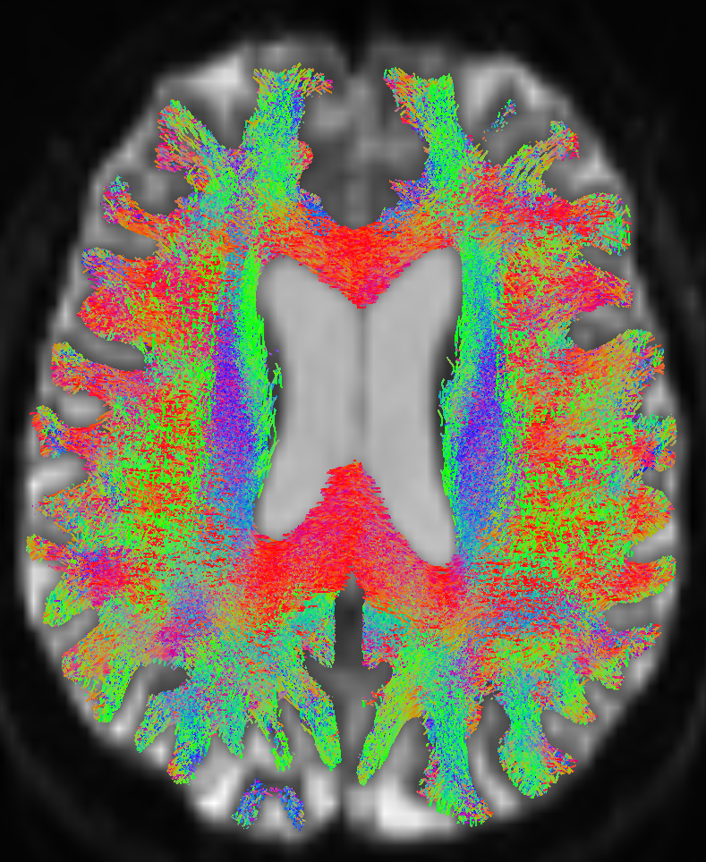

Result of streamline generation by ACT which is displayed as an overlay on the DW image. The tracks are colour-coded – red indicates streamlines from right to left, green from anterior to posterior, blue from superior to inferior. Note that the streamlines terminate reliably at the gray-matter/white-matter-boundary. This is a result of ACT.

*Smith et al., (2012). Anatomically-constrained tractography: Improved diffusion MRI streamlines tractography through effective use of anatomical information*

Elapsed time: 3 sec

1. **Refine streamlines with SIFT**

Like in the previous FBA script, we will need to perform the Spherical-deconvolution Informed Filtering of Tractograms (SIFT) to reduce tractography biases and overfitting which may contribute to false positives. This will help reduce tracts rom being overly-represented by the amount of streamlines that pass through them not necessarily because they contain more fibres, but because the fibres tend to all be orientated in the same direction. You should also pass the 5TT image to tcksift using the -act option. And again, you shouldn’t use a brain mask if you are using the 5TT image for the tissue constriction.

Command: tcksift2 -act

%Sample output: sift_1M_sub-ADPRC0001F0.txt

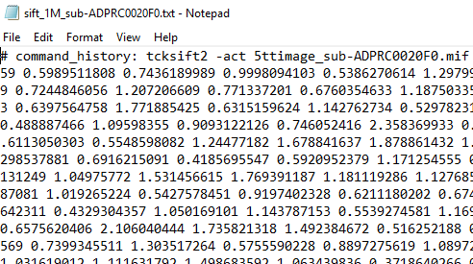

The output text file containing 1 million values.

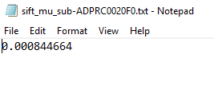

The mean (mu) of all the values?

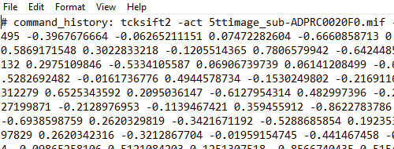

Coefficient values.

Elapsed time: 15 -25 min (may vary with each participant?)

<https://community.mrtrix.org/t/handling-sift2-weights/2242>

<https://community.mrtrix.org/t/sift2-weights-streamlines-lengths/2325>

<https://community.mrtrix.org/t/new-tractography-by-using-a-weights-csv-file/4181>

Also, we need to generate a .tck 1M SIFT file, which will be used for connectome visualisation later on.

Command: tcksift -act

%Sample output: sift_1M_sub-ADPRC0001F0.tck

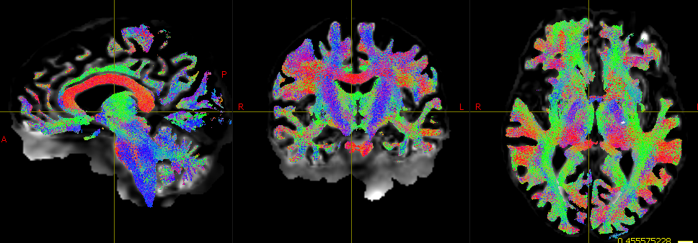

Tractography image sifted down to 1 million streamlines, overlayed on the white matter fibre density normalised (wmfod_norm.mif) image.

Elapsed time: 2 hours - 8 hours and 57 min (may vary with each participant?)

You can see the difference with SIFT if you view the tracts on a smaller scale, say with 10,000 tracts. Use tckedit to view this difference, like below:

**NO SIFT SIFT**

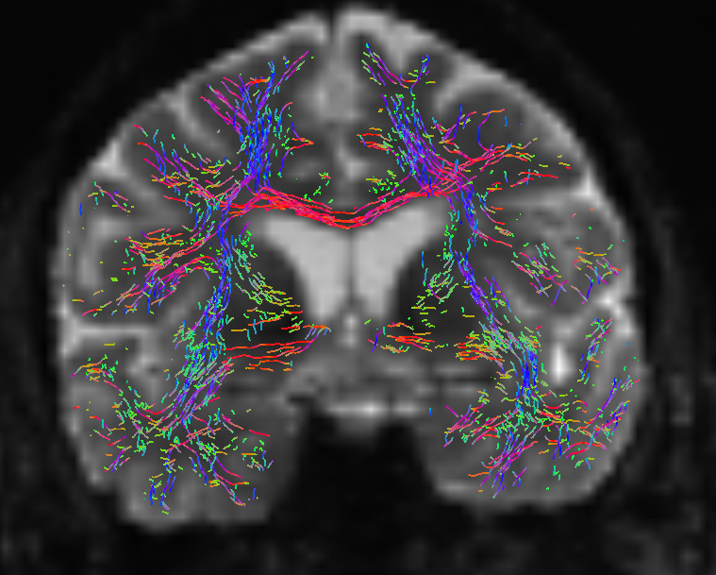 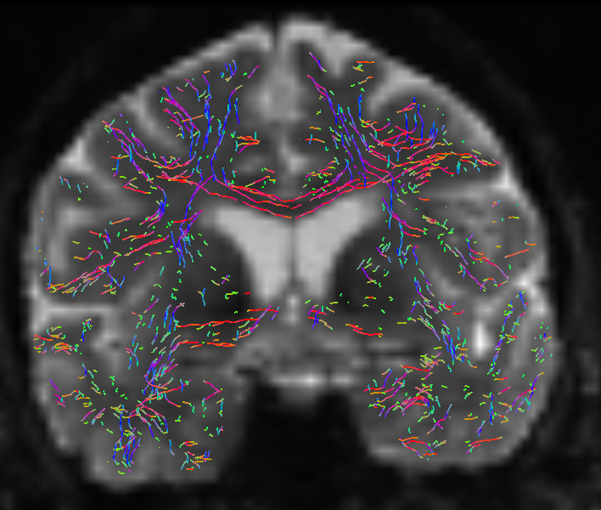

Result of using SIFT on the tracts. Both images are comprised with ten thousand (10k) tracks overlayed on the white matter DW image. Without SIFT, tracts such as the corpus callosum, are overestimated. SIFT corrects for this bias.

1. **Create the connectome**

Once we have the parcellations per each participant, we will now have to convert these labels to mrtrix format and create the whole brain connectome.

Option 1: Create an 84 x 84 connectome (simple)

* 1. **Convert labels to MRtrix format**

We need to convert the labels of the used atlas (e.g. such as from FreeSurfer) into a format that MRtrix understands. This command takes an input parcellation image and converts the label indices; this is done so that the code that actually generates the connectome can be ‘dumb and blind’, i.e. the integer values at the streamline endpoints correspond to the row & column of the connectome matrix that should be incremented. The default FreeSurfer pipeline provides the volumetric image *aparc+aseg.mgz* (located in the subject/mri folder); this is the file that will be used to define the nodes of our connectome. This particular file will create an 84x84 matrix for our connectome – you can choose other atlases for a different number – see BATMAN tutorial for further information. You will also need to use FreeSurfer’s colour text file (FreeSurferColorLUT.txt), located in the FreeSurfer home directory:

Command: labelconvert

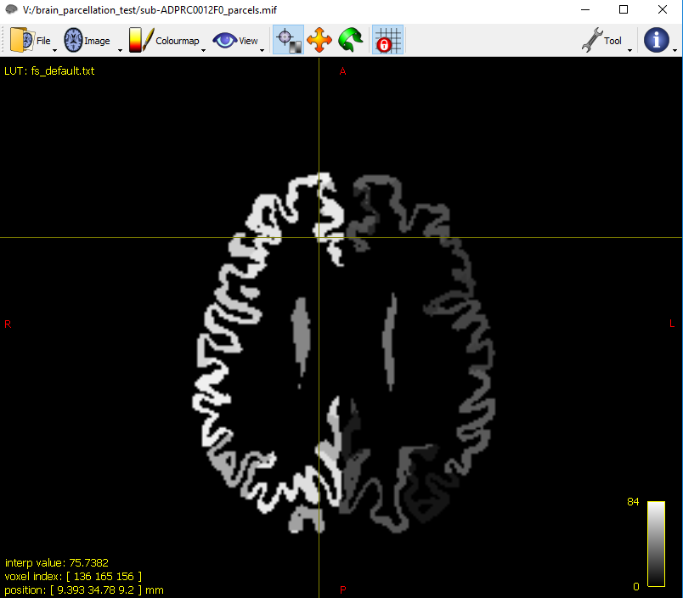

This is the parcellation image which has been converted to mrtrix formatting, with using the text files from both FreeSurfer and MRtrix.

We will be using *FreeSurferColorLUT.txt* and the *fs_default.txt* and the for this.

labelconvert is a rather hard command to use / understand, and so there is a complete documentation with a provided example on this via mrtrix: <https://mrtrix.readthedocs.io/en/latest/quantitative_structural_connectivity/labelconvert_tutorial.html>

Elapsed time: 2 sec

* 1. **Co-register the parcellation to the grey matter boundary**

If you used mrtransform earlier to coregister the grey matter boundary, then you should use it again here to also coregister the parcellation.

Command: mrtransform

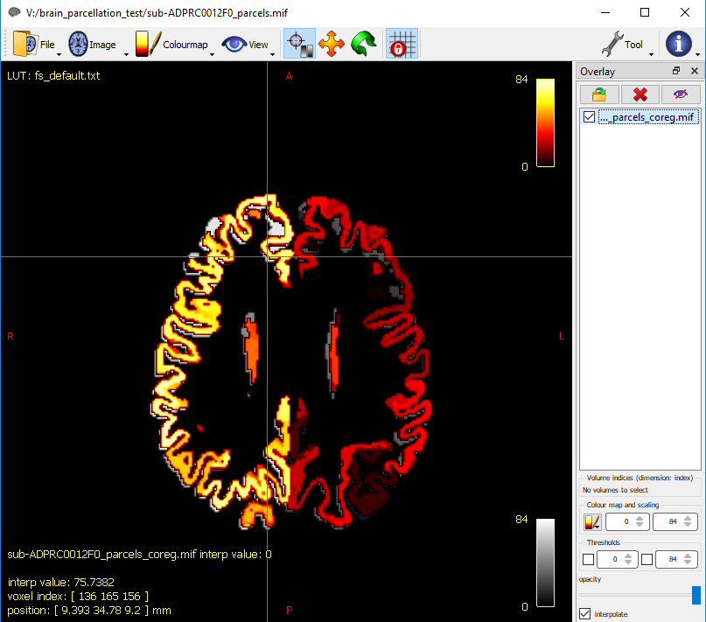

The coregistered parcellated image (in hot colours) overlayed on the parcellated image.

Elapsed time: < 1 sec

* 1. **Create the whole-brain connectome**

We will now generate the connectome through converting the tracts into a connectome matrix, based on the provided parcellated image. By default, the streamline count is used as the connectivity metric; run tck2connectome -help to see alternative heuristics / measures.

Command: tck2connectome

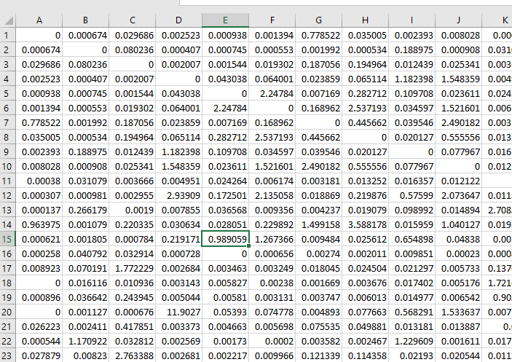 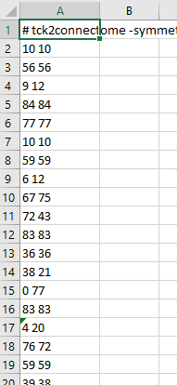

**_parcels_coreg.csv assignment_parcels_coreg.csv**

Elapsed time: 3 min

The **_parcels_coreg.csv** file (on the left) contains the atlas regions on each cortical hemisphere (left and right). Each cell represents the correlation of the structural connection of one region to another region, as specified by the atlas (see below). These values then contribute to how bright the connectome matrix is, with a brighter value indicating a stronger structural connection, with each location of the boxes signifying different types of regional connections. See below for the visualisation of this (i.e. the blue boxes).

The **assignment_parcels_coreg.csv** file (on the right) contains the 1 million streamline values from the sift tractography file that we generated earlier. The values in the cell represent the number of regions that the generated streamlines pass through. With the default atlas from MRtrix (fs_default.txt), there is a maximum of 84 regions that the streamlines can pass through. There are typically 2 indices per row, which correspond to the two parcels, to which each streamline was assigned during connectome construction. This file is not needed for the generation of the structural connectome matrix, and is therefore not needed for the whole brain connectome, but is necessary a connectome of interest, which is looking at tracts and regions of interest.

<https://community.mrtrix.org/t/please-give-an-example-of-the-assignment-text-file-in-connectome2tck/714>

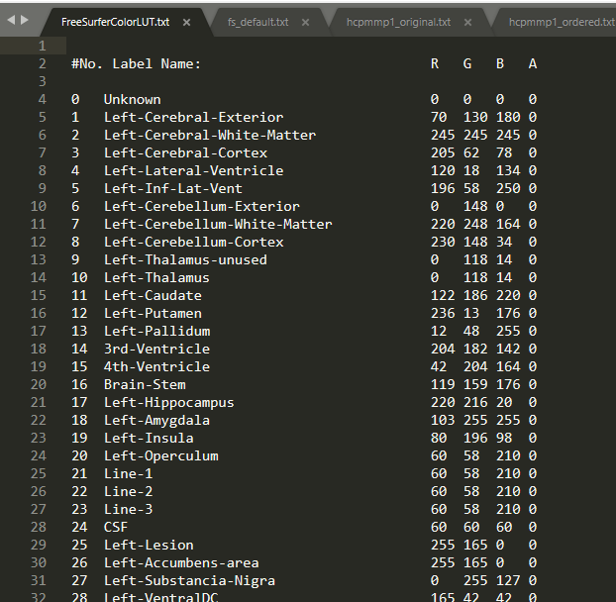

This is the FreeSurferColorLUT.txt file found in the FreeSurfer directory (e.g. $FREESURFER_HOME/FreeSurferColorLUT.txt). It contains all FreeSurfer labels for the regions (a total of 14,175 regions).

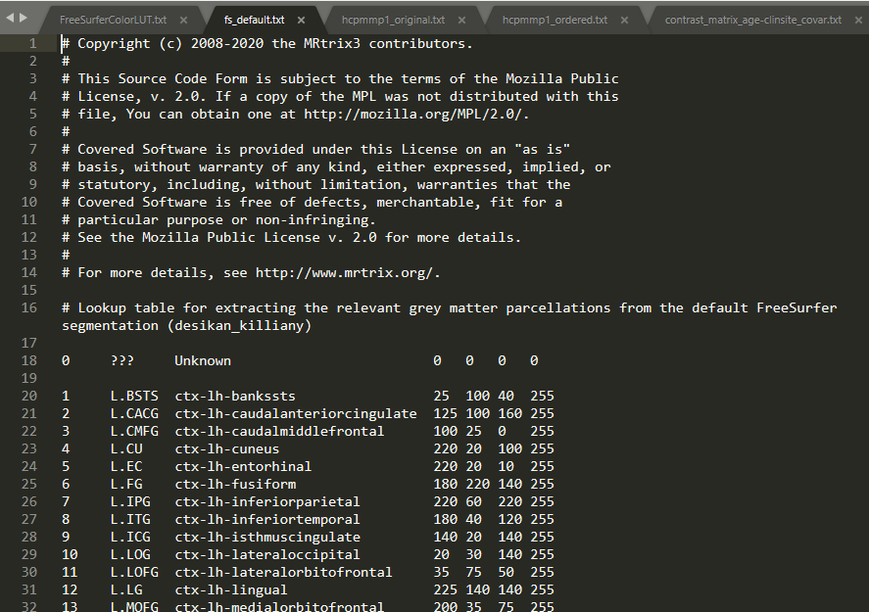

This is the fs_default.txt file found in MRtrix’s shared file folders (e.g. /data/SOFTWARE/mrtrix3/share/mrtrix3/labelconvert/fs_default.txt). This file contains 84 regions (42 for the left hemisphere, and 42 for the right hemisphere).

You can then view the connectome matrix as an image through Matlab using a Matlab specific command.

Command: connectome = importdata(matrix file.csv)

imagesc(connectome)



An 84x84 matrix representing the structural connectome. The two ‘boxes’ in the upper left and bottom right corners represent the structural connectivity within each hemisphere of the brain. Brighter smaller boxes represent increased structural connectivity between the nodes. A noticeably, brighter diagonal line represents higher structural connectivity between nearby nodes. See below for a visualisation of this interpretation.

To make the associations more obvious, you can change the colour scaling on the map:

Command: imagesc(connectome, [0 1]);



Option 2: Use the HCP MMP 1.0 atlas – 379 x 379 connectome



Here is another connectome matrix (379x379), which is based upon the *Human Connectome Project Multi-Modal Parcellation 1.0* (HCP MMP 1.0) atlas (Glasser et al., 2016). To use this atlas (the HCP MMP 1.0 atlas) for your data, you can follow the B.A.T.M.A.N tutorial. You will need to download the atlas files and put them in the necessary FreeSurfer directory, which is outlined in the appendix section of their tutorial.

1. Map the annotation file of the HCP MMP 1.0 atlas from fsaverage to your subject. Remember to do that for both hemispheres.

This will create file for each hemisphere in the participant folder.

Command: mri_surf2surf

%Sample output: lh.hcpmmp1.annot (in participant’s FreeSurfer subject folder)

E.g.

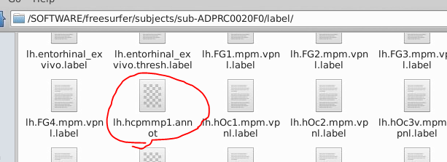

Elapsed time: 17 sec

1. Map the HCP MMP 1.0 annotations onto the volumetric image and add (FreeSurfer-specific) subcortical segmentation. Convert the resulting file to .mif format (use datatype uint32, which is liked best by MRtrix).

Command: mri_aparc2aseg

mrconvert

%Sample output: sub-ADPRC0001F0_hcpmmp1.mgz

sub-ADPRC0001F0_hcpmmp1.mif



With T1w image used only during parcellation (recon-all).



With both T1w and FLAIR used, you can see that the parcellation is much more stricter on the tissue (overlayed on top for comparison).

Elapsed time: 11 min

1. Replace the random integers of the hcpmmp1.mif file with integers that start at 1 and increase by 1.

We will be using the hcpmmp_original.txt and the hcpmmp_ordered.txt for this.

Command: labelconvert

%Sample output: sub-ADPRC0001F0_hcpmmp1_parcels_nocoreg.mif

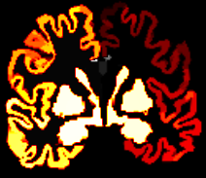

Added in the regions from the HCP MMP 1.0 atlas overlayed on top of the parcellated image.

Elapsed time: < 1 sec

1. Register the ordered atlas-based volumetric parcellation to diffusion space.

Command: mrtransform

%Sample output: sub-ADPRC0001F0_hcpmmp1_parcels_coreg.mif

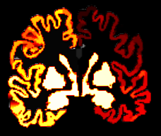

A slight shifting/adjustment occurred to register the atlas parcellated image onto the diffusion space.

Elapsed time: 1 sec

1. Create the whole-brain connectome

Command: tck2connectome

%Sample output: hcpmmp1_sub-ADPRC0001F0.csv (on left)

assignments_hcpmmp1_sub-ADPRC0001F0.csv (on right)

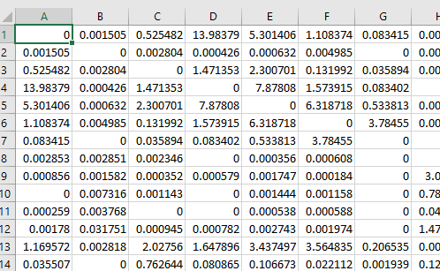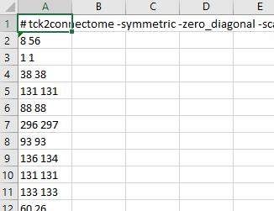

Elapsed time: 2 min

The **_parcels_coreg.csv** file (on the left) contains the atlas regions on each cortical hemisphere (left and right). In our case, we are using the HCP MMP 1.0 atlas, which contains 180 regions (360 with both sides), plus 19 subcortical regions (total 379 regions), based on the FreeSurfer segmentation. Each cell represents the correlation of the structural connection of one region to another region, as specified by the atlas (see below). These values then contribute to how bright the connectome matrix is, with a brighter value indicating a stronger structural connection, with each location of the boxes signifying different types of regional connections. See below for the visualisation of this (i.e. the blue boxes).

The **assignment_parcels_coreg.csv** file (on the right) contains the 1 million streamline values from the sift tractography file that we generated earlier. The values in the cell represent the number of regions that the generated streamlines pass through. Since we are using the hcpmmp1 atlas, then there is a maximum of 379 regions that the streamlines can pass through. There are typically 2 indices per row, which correspond to the two parcels, to which each streamline was assigned during connectome construction. This file is not needed for the generation of the structural connectome matrix, and is therefore not needed for the whole brain connectome, but is necessary a connectome of interest, which is looking at tracts and regions of interest.

<https://community.mrtrix.org/t/please-give-an-example-of-the-assignment-text-file-in-connectome2tck/714>

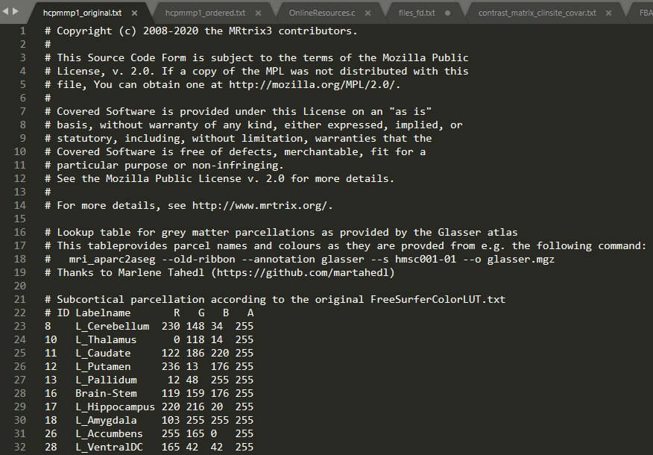

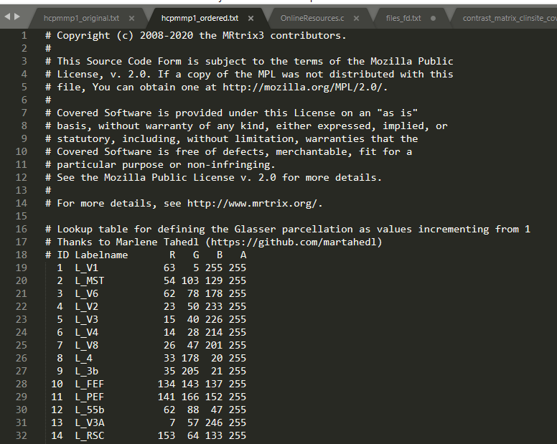

This file contains 379 regions (180 each for left + right hemisphere, plus 19 subcortical regions).

Like in the previous default atlas, you can visualise the connectome in Matlab

Command: connectome = importdata(matrix file.csv)

imagesc(connectome)

imagesc(connectome, [0 .1]);



Beautiful connectome~! Parcellation was done based upon the HCP MMP 1.0 atlas (379 x 379 matrix).

Interpretation of the location of the bright areas ( = stronger connectivity), as specified by the B.A.T.M.A.N tutorial (see below):

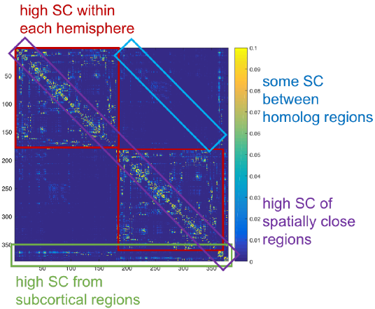

Brighter areas represent stronger structural connectivity within certain locations (as specified by the colours. The **red** boxes show intrahemispheric connections within the left hemisphere (upper left) and within the right hemisphere (lower right). The bright main diagonal line enclosed by the **purple** box represents high structural connectivity between spatially close regions. The last rows/columns outlined in the **green** box represent regions structurally connected to the subcortical regions. The **blue** box represents the structural connections between the so-called ‘homolog’ regions, i.e. corresponding regions on the right and left hemispheres, e.g., the right and left premotor cortices.

1. **Select a specific tract and region from the connectome**

If you are interested in looking at how strongly specific nodes / regions connect to each other, you can select this specifically. We will be using the HCP MMP 1.0 atlas for selecting the regions of interest.

For example, if you are interested in the motor cortex, you need to identify the regions and match them with the atlas which correspond to the left and right motor cortices (Glasser et al., 2016). The atlas specifies that the motor cortex is called ‘4’, which would be ‘L_4’ and ‘R_4’ for the left and right hemispheres, respectively. You look up these regions on the colour lookup table (hcpmmp1_ordered.txt), and find that this would correspond to indices 8 and 188. You want to then enter these MRtrix indices in the MRtrix command below:

Command: connectome2tck

%Sample output: sub-ADPRC0001F0_moto8-188.tck

You can also calculate the regions of interest from the atlas by using mrcalc. E.g.:

mrcalc sub-ADPRC0020F0_hcpmmp1_parcels_coreg.mif 8 -eq sub-ADPRC0020F0_L_4.mif (for the left hemisphere).

mrcalc sub-ADPRC0020F0_hcpmmp1_parcels_coreg.mif 188 -eq sub-ADPRC0020F0_R_4.mif (for the right hemisphere).

If you have multiple nodes and regions, you can add them together as one image, after calculating a region per each node…ex:

mrcalc sub-ADPRC0020F0_hcpmmp1_parcels_coreg.mif 73 -eq sub-ADPRC0020F0_L1-DLPFC.mif

mrcalc sub-ADPRC0020F0_hcpmmp1_parcels_coreg.mif 67 -eq sub-ADPRC0020F0_L2-DLPFC.mif

...

mrcalc sub-ADPRC0020F0_L1-DLPFC.mif sub-ADPRC0020F0_L2-DLPFC.mif [...] -add sub-ADPRC0020F0_L_DLPFC.mif

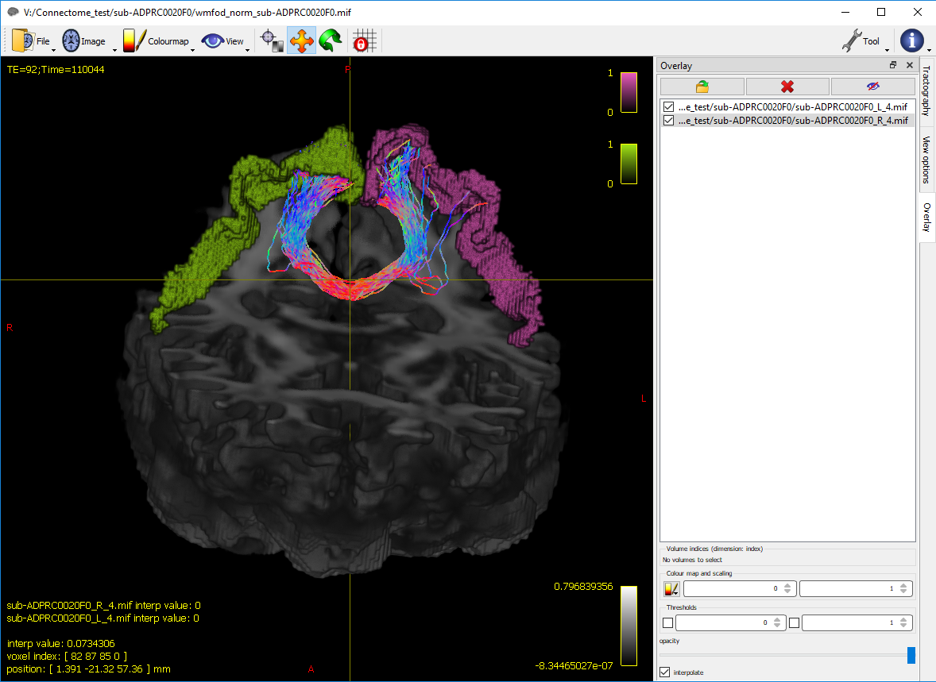

This image is displaying the streamlines between the motor cortices (left and right motor cortex – 8, 188 indices), overlayed on the wmfod_norm image. The motor cortices have been calculated with MRtrix, and are able to be displayed together with the generated motor tracks.

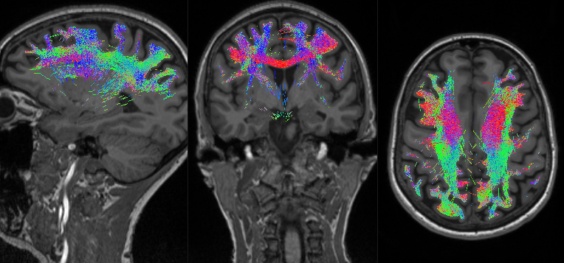

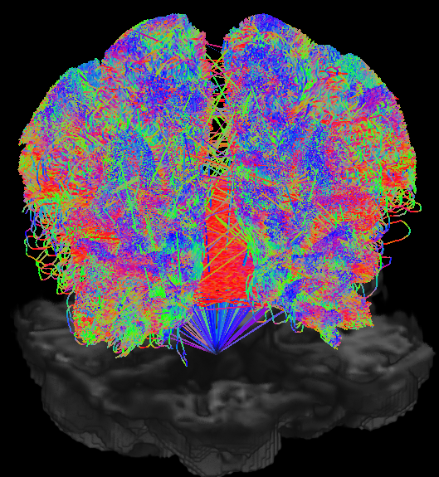

Another example of the interested network that I am interested in, which is the frontoparietal network (FPN). The FPN includes the dorsolateral prefrontal cortex (DLPFC), the mid cingulate cortex, the superior parietal cortex, the inferior parietal cortex, and the intraparietal sulcus (IPS). Using the HCP MMP 1.0 atlas (Glasser et al., 2016a, 2016b), I selected **41 nodes**, for a total of **82 nodes**, including for the left and right hemisphere.

Now that you have your interested network of tracks (e.g. FPN), you need to convert this back into a connectome file.

1. **Perform group-wise statistics of the connectome using non-parametric permutation testing**

In order to compare differences between our groups, we need to run statistics on our connectomes. The MRtrix command ‘connectomestats’ requires a text file listing the file names of the input connectomes (the .csv matrix file), an algorithm (NBS, TFNBS or none), a design and contrast matrix, and prefix for the output file.

Similar to ‘fixelcfestats’ in the FBA analysis, ‘connectomestats’ will run a statistical enhancement (the specified algorithm), group-wise statistics, using non-parametric permutation testing, with a family-wise error of p < .05.

For the algorithm, we will be using the **threshold-free network-based statistics (TFNBS)** algorithm. You can read more about the different algorithms here:

TFNBS:

*Baggio, H. C., Abos, A., Segura, B., Campabadal, A., Garcia-Diaz, A., Uribe, C., … Junque, C. (2018). Statistical inference in brain graphs using threshold-free network-based statistics.*

For the TFNBS algorithm, default parameters for statistical enhancement have been set based on the work in:

*Vinokur, L., Zalesky, A., Raffelt, D., Smith, R. E., & Connelly, A. (2015b). A Novel Threshold ­ Free Network ­ Based Statistics Method : Demonstration using Simulated Pathology.*

*Vinokur, L., Zalesky, A., Raffelt, D., Smith, R. E., & Connelly, A. (2015a). A Novel Threshold-Free Network-Based Statistical Method: Demonstration and Parameter Optimisation Using in Vivo Simulated Pathology.*

NBS:

*Zalesky, A., Fornito, A., & Bullmore, E. T. (2010). Network-based statistic: Identifying differences in brain networks.*

On the other hand, when conducting statistics on an interested network (i.e. not whole brain, but e.g. FPN), then you should use MRtrix’s ‘vectorstats’ command, which does correct for family-wise error (p < .05) and a non-parametric permutation testing, but no statistical enhancement algorithm is implemented.

1. **On whole-brain connectome (all nodes)**

%Sample Input text file containing the list of the file names of the input connectomes (e.g, a .txt files containing a list of these contents: *hcmmp1_sub-ADPRC0001F0.csv*)

Command: connectomestats

Elapsed time: 28 min (with 28 participants, C vs. AD, with 1 covar)

%Sample output (several .csv output files):

output_connectome_stats_beta_0.csv

output_connectome_stats_enhanced_t1.csv

output_connectome_stats_fwe_1mpvalue_t1.csv – list of p-values (1-pvalue) per each edge-wise connection in the connectome matrices (e.g., 379 x 379). If the value within the cell is greater than .95 (p-value set at 0.05), then that connection was significant.

output_connectome_stats_null_contributions_t1.csv

output_connectome_stats_tvalue_t1.csv

output_connectome_stats_uncorrected_pvalue_t1.csv

output_connectome_stats_Zstat_t1.csv

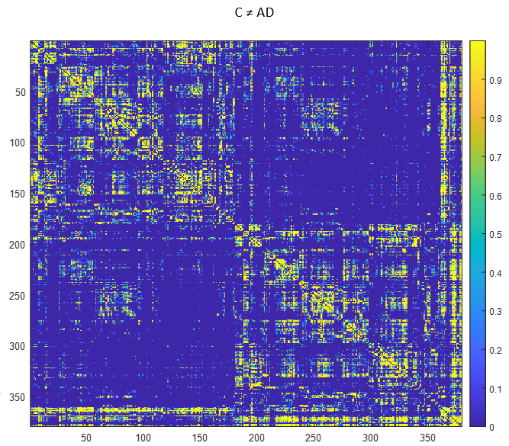

Group differences between healthy controls (C) and individuals with Alzheimer’s disease (AD). A one-tailed t-test checked whether there were differences between the groups. Brighter areas (yellow) indicate a larger difference, and darker areas (dark blue) indicate smaller or no differences.

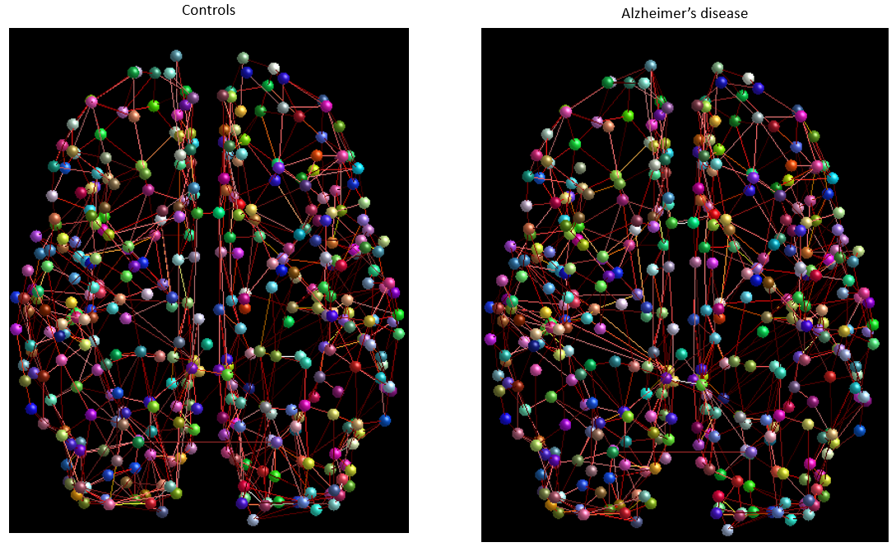 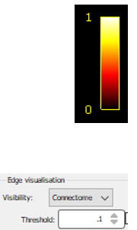

Node visualisation averages between healthy controls (C) and individuals with Alzheimer’s disease (AD). Connectome edges are thresholded by 0.1 on a range from 0 to 1 Data is overlayed on the subject average template.

You can also create a template to visualise the connectome as nodes in the MRtrix GUI (mrview). This will take the fsaverage image from FreeSurfer’s subject directory ($SUBJECTS_DIR/fsaverage/) and create a template that is compatible with the HCP MMP 1.0 atlas for MRtrix.

Command: CreateConnectomeTemplate (in-house function)

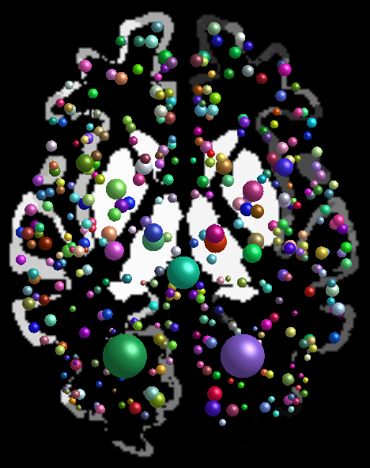

Fsaverage template with the Glasser HCPMMP 1.0 atlas

1. **On nodes / connections of interest**

For my analysis, I am interested in the frontoparietal network (FPN), and so I will be selecting all nodes pertaining to this network. This is detailed in ‘FPN-description_HPC-atlas.docx.’

Command: vectorstats

Elapsed time: 1 sec (with 28 participants, C vs. AD, with 1 covar)

%Sample output (several .csv output files): output_connectome_stats_fwe_1mpvalue_t1.csv

If you are interested in just analysing a subset of notes, then you can just select from the matrix data the elements in which are you are interested in.

<https://community.mrtrix.org/t/connectomestats-fwe-correction/3348/2>

<https://community.mrtrix.org/t/use-connectomestats-to-compare-two-groups/4255>

As mentioned before, like the fixel statistics (i.e. fixelcfestats) in the FBA pipeline, the connectome statistics also use the similar GLM permutation, based on this paper:

*Winkler, A. M., Ridgway, G. R., Webster, M. A., Smith, S. M., & Nichols, T. E. (2014). Permutation inference for the general linear model.*

1. **Options for connectome visualisation**

To view the connectome with nodes and edges, load the hcpmmp1_parcels_coreg.mif as the **main file** and as the **node image**, and the hcpmmp1.csv as the **connectome matrices**. Below, we are looking at a single participant’s connectome.

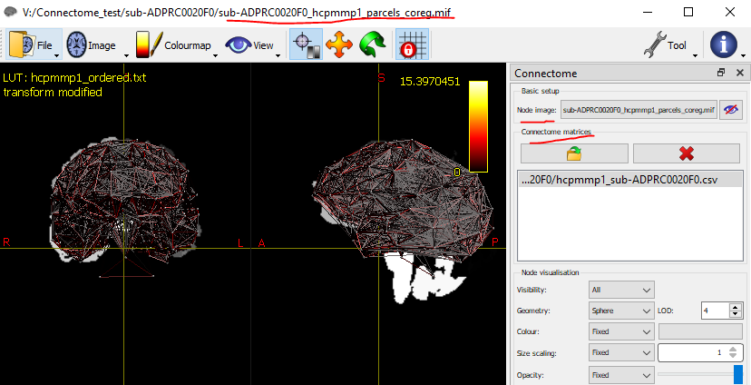Also press ‘m’ to hide the main image (or hide the main image from the ‘View’ dropdown menu at the top tab), as this is not needed to be seen for the connectome.

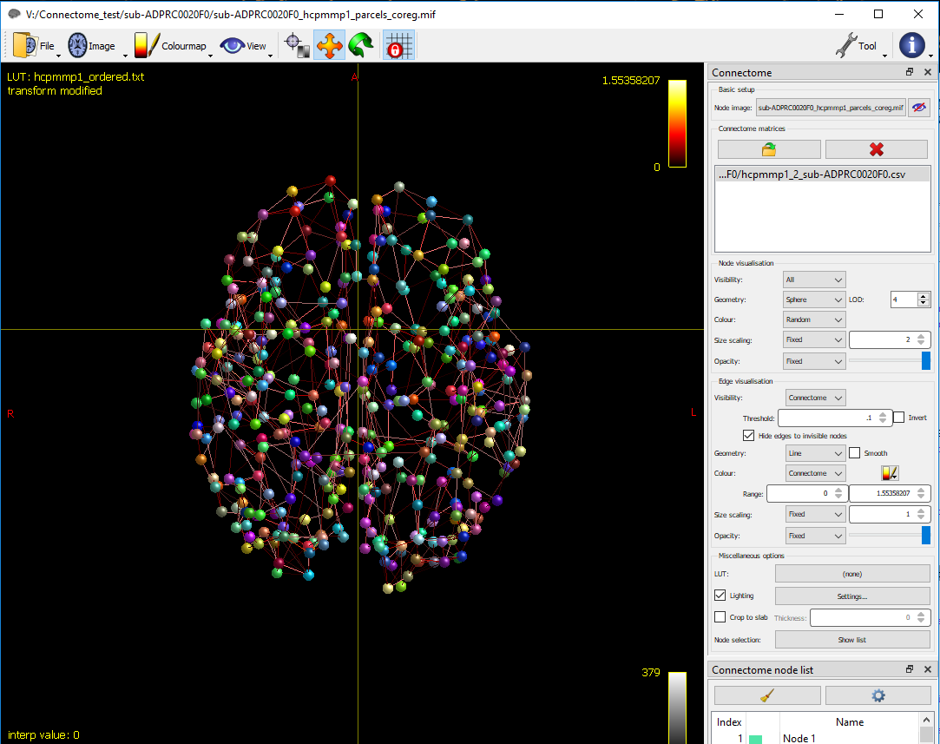

Have a play around with changing the visualization settings. For instance, I adjusted the threshold for the edges (.1), changed the sphere size to be larger (2), and set the nodes to random colours.

If you are interested in a certain network (e.g. FPN), you can just select the nodes of the network, as shown below.

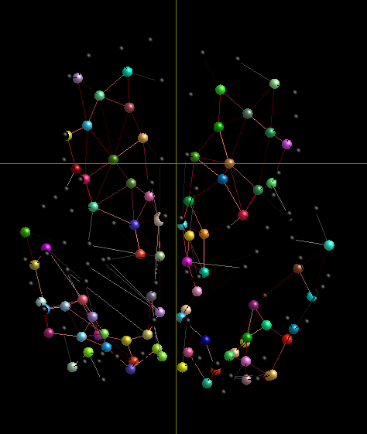 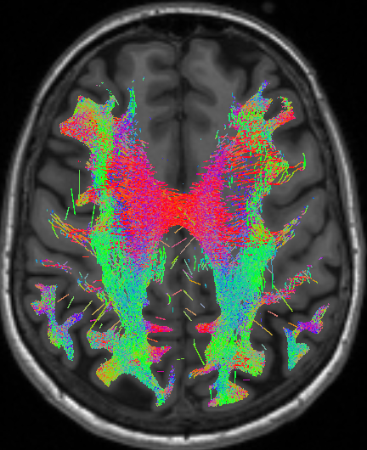

The FPN ‘nodes’ displaying the DLPFC, the midcingulate cortex, the superior and inferior parietal lobules, and the intraparietal sulcus (Uddin, Yeo, & Spreng, 2019) - shown on the left. Looks similar to the tractography version of the FPN (shown on the right).

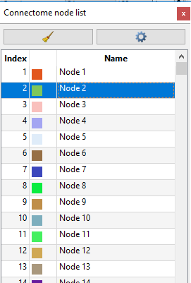

Select the node numbers (use cntrl+ to select multiple) to display them onscreen.

1. **To make the connectome appear more ‘anatomical’….**

Make the node geometry as meshes

Command: label2mesh

%Sample output: sub-ADPRC0001F0_hcpmmp1_mesh_coreg.obj



.obj file shown in Matlab.

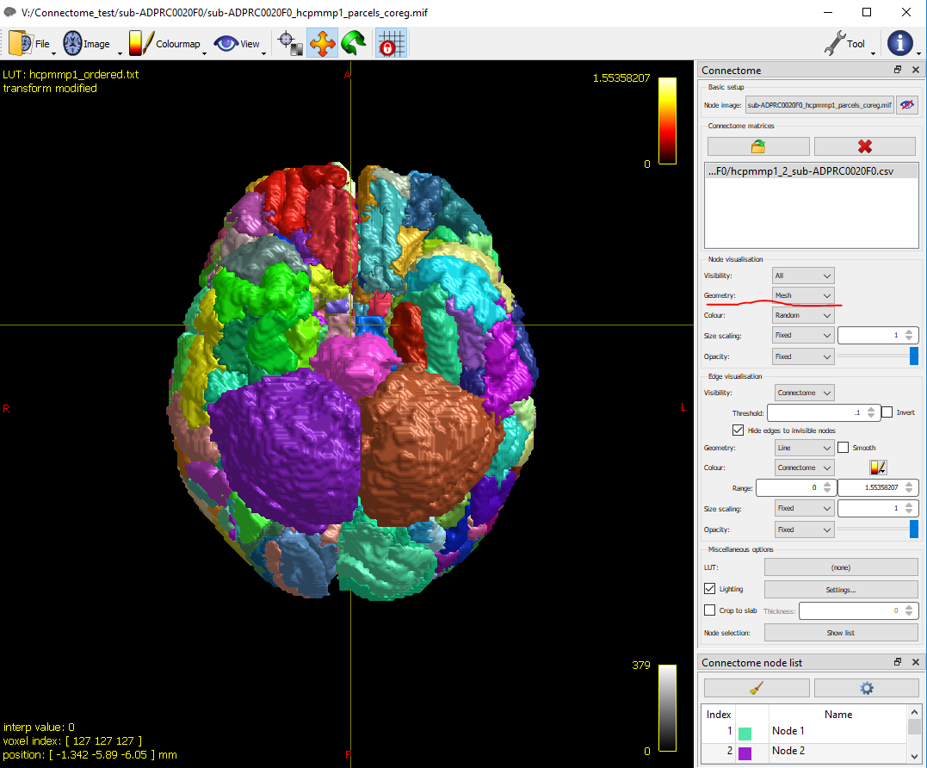

Once you have generated the .obj file, then load this into the geometry by choosing ‘mesh’ in the dropdown option.

Change the edge geometry to streamlines

Command: connectome2tck

%Sample output: sub-ADPRC0001F0_edge.tck

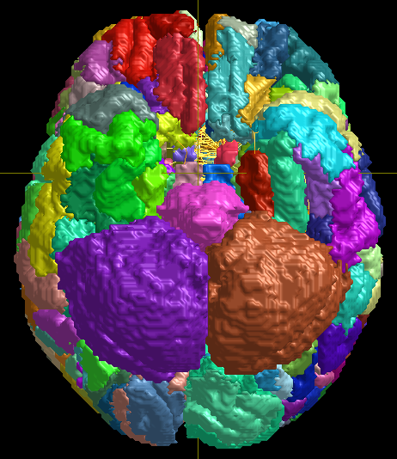

You cannot see that much changes at all, since all of the regions are being shown and blocking the streamlines. So, you can create and load in a .csv vector file for the viewing the interested nodes and have better visibility of the edges.

The .csv file needs to be in logical format, so that the visible nodes are demarcated as a ‘1’ and the non-visible nodes are demarcated as a ‘0’, which are all put into the 1st row.

E.g.

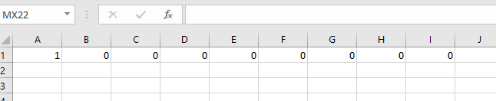

This file contains 1 row of 0s and 1s for 379 cells (for the 379 regions from the HCP MMP 1.0 atlas).

Load in this file in the GUI, by selecting ‘vector’ from the dropdown menu of the ‘visibility’, under ‘node visualisation’.

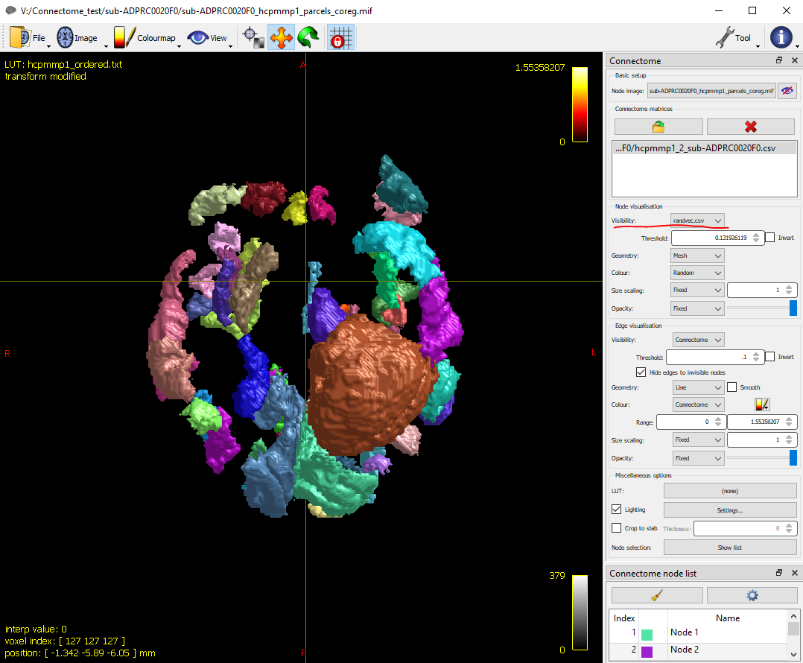

I have loaded in a vector with random logical values. You can change by changing the vector file (e.g. choosing your interested nodes).

You can now visualise the edges (the streamlines) better with less regions shown. In the ‘edge visualisation’ section, choose ‘streamline’ from the ‘geometry’ menu, and load in the edge.tck.

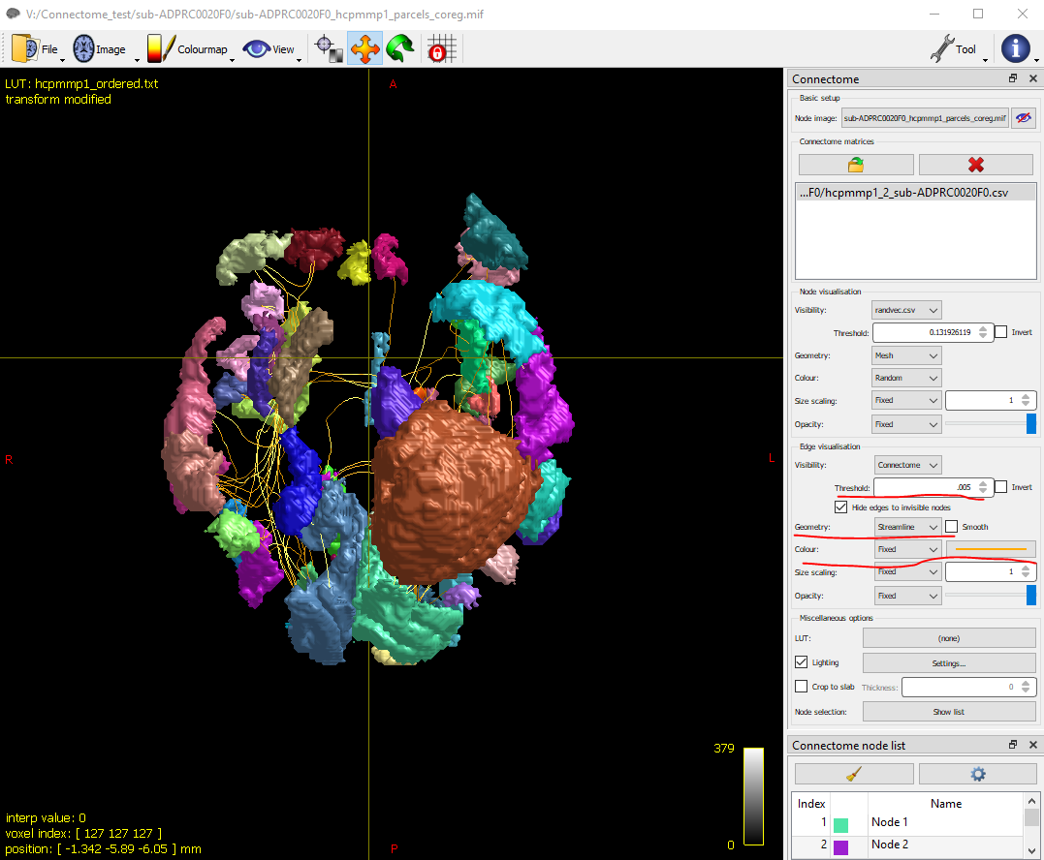You can also set the threshold to be smaller (.005) and make the steamline colour as fixed.

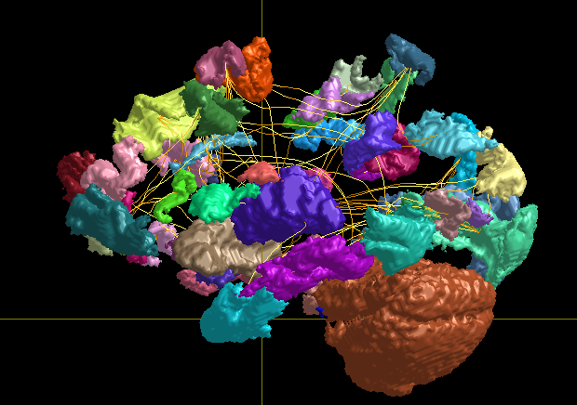

Sagittal view of the same brain and nodes.

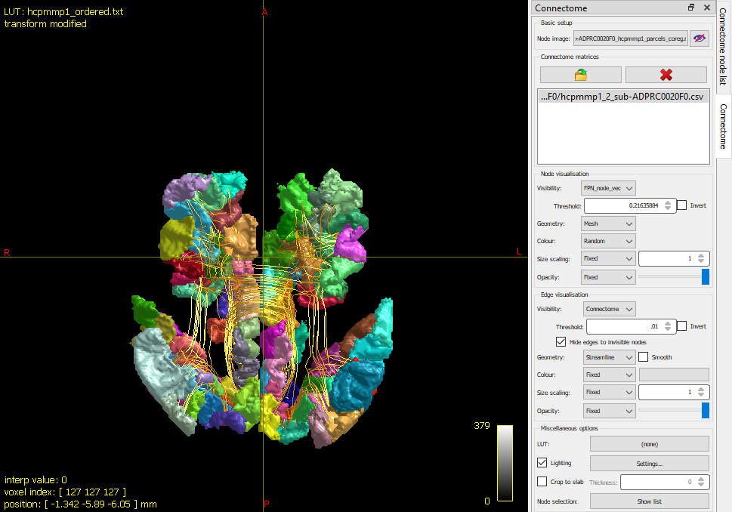

Example of the FPN regions and streamline connections.

A documentation on using MRtrix’s connectome visualization tool: <https://mrtrix.readthedocs.io/en/latest/quantitative_structural_connectivity/connectome_tool.html>

More info on connectome viewing with other software: <https://community.mrtrix.org/t/visualising-processing-tck2connectome-output/1941/5>

<https://mne.tools/stable/auto_examples/connectivity/plot_mne_inverse_label_connectivity.html>

If you are interested in more in-depth connectome metric analyses, such as graph theory, you can use the BCT toolbox from Matlab: <https://community.mrtrix.org/t/graph-theory-measures/2427>

If you want to rotate your brain, you can set up these settings in the ‘Screen Capture’ screen in MRView.

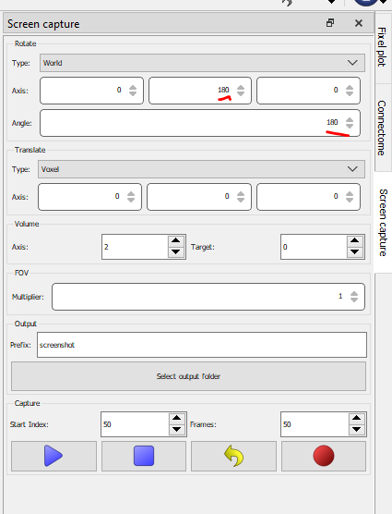

This will rotate your brain, which will let you view it from left and right in the axial view.

1. **Check over connectome files – examples of ‘bad’ files.**

It is good to check whether the parcellations for each participant were done correctly by FreeSurfer. Beware that incorrect parcellations can occur, and manual checking is needed to be done.

For example, I found that with one participant, the right hemisphere (lower right) had a much brighter area compared to the left hemisphere (upper left).



*This connectome matrix is from a DPRC participant. Perhaps the brighter right bottom square may demonstrate that there is greater structural connectivity within their right hemisphere as opposed to within their left hemisphere….or actually this just might be parcellated incorrectly by FreeSurfer.*

Also, a very ‘bright’ connectome may indicate a mistake. Here, I mistakenly added 10 million tracks as part of the assignment file, which makes it brighter, indicating stronger connections, as opposed to other participants with 1 million streamlines in their file.



This resulted in a cluster of nodes appearing on the right hemisphere as seen below, and the anatomical representation also appeared ‘speckled’ and ‘disintegrated’ on the right hemisphere.

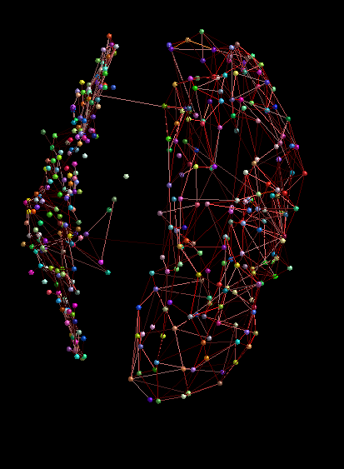

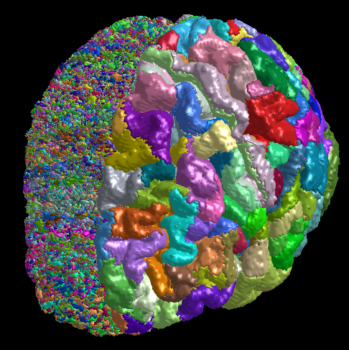 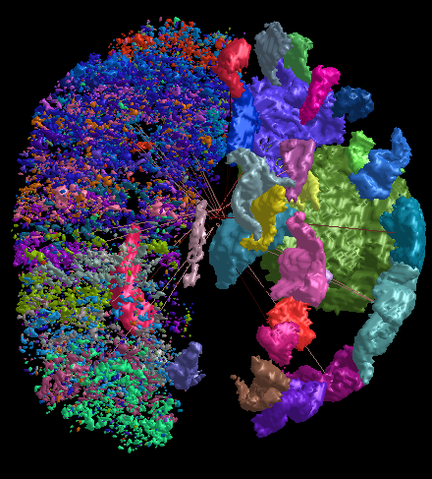

<https://community.mrtrix.org/t/wrong-position-of-connectome-nodes/2172/2>

Resources available for the HCPMMP 1.0 atlas (Glasser et al., 2016):

<https://neuroimaging-core-docs.readthedocs.io/en/latest/pages/atlases.html>

* Includes list/table of regions (379) and cortices (44)
* MNI centre of gravity in voxel coordinates the volume in cubic mm for each of the regions and cortices

References

Baggio, H. C., Abos, A., Segura, B., Campabadal, A., Garcia-Diaz, A., Uribe, C., … Junque, C. (2018). Statistical inference in brain graphs using threshold-free network-based statistics. *Human Brain Mapping*, *39*(6), 2289–2302. https://doi.org/10.1002/hbm.24007

Esteban, O., Markiewicz, C. J., Blair, R. W., Moodie, C. A., Isik, A. I., Erramuzpe, A., … Gorgolewski, K. J. (2019). fMRIPrep: a robust preprocessing pipeline for functional MRI. *Nature Methods*, *16*(1), 111–116. https://doi.org/10.1038/s41592-018-0235-4

Glasser, M. F., Coalson, T. S., Robinson, E. C., Hacker, C. D., Harwell, J., Yacoub, E., … Van Essen, D. C. (2016a). A multi-modal parcellation of human cerebral cortex. *Nature*, *536*(7615), 171–178. https://doi.org/10.1038/nature18933

Glasser, M. F., Coalson, T. S., Robinson, E. C., Hacker, C. D., Harwell, J., Yacoub, E., … Van Essen, D. C. (2016b). Supplementary Neuroanatomical Results For A Multi-modal Parcellation of Human Cerebral Cortex. *Nature*, *536*(7615), 1–97. https://doi.org/doi:10.1038/nature18933 Supplementary

Pruim, R. H. R., Mennes, M., van Rooij, D., Llera, A., Buitelaar, J. K., & Beckmann, C. F. (2015). ICA-AROMA: A robust ICA-based strategy for removing motion artifacts from fMRI data. *NeuroImage*, *112*, 267–277. https://doi.org/10.1016/j.neuroimage.2015.02.064

Schmidt, P. (2016). *Bayesian inference for structured additive regression models for large-scale problems with applications to medical imaging. Dissertation, LMU München: Faculty of Mathematics, Computer Science and Statistics*. Retrieved from https://edoc.ub.uni-muenchen.de/20373/

Schmidt, P., & Wink, L. (2019). *LST : A lesion segmentation tool for SPM*. Retrieved from https://edoc.ub.uni-muenchen.de/20373/

Uddin, L. Q., Yeo, T. B. T., & Spreng, N. R. (2019). Towards a universal taxonomy of macro-scale functional human brain networks. *Brain Topography*, *32*(6), 926–942. https://doi.org/10.1007/s10548-019-00744-6

Zalesky, A., Fornito, A., & Bullmore, E. T. (2010). Network-based statistic: Identifying differences in brain networks. *NeuroImage*, *53*(4), 1197–1207. https://doi.org/10.1016/j.neuroimage.2010.06.041

**Notes:**

1. With using Fmriprep via Docker to preprocess the anatomical images and run FreeSurfer’s recon-all parcellation, I found that too much space was being taken up in the filesystem (specifically, in the /var/lib/docker directory), which was problematic (e.g. this was messing with recon-all). And so, I opted to move this directory onto a mounted volume drive, as followed by this website: <https://www.guguweb.com/2019/02/07/how-to-move-docker-data-directory-to-another-location-on-ubuntu/>
2. Another parallelization option is to utilize several CPUs per running each subject, as outlined here. You will need to download ‘HomeBrew’ and then install ‘parallel’ with HomeBrew to do this. <https://andysbrainbook.readthedocs.io/en/latest/FreeSurfer/FS_ShortCourse/FS_04_ReconAllParallel.html>

<https://blog.cogneurostats.com/2013/06/10/parallelizing-freesurfer/>



Example of parallel command (run in terminal):

ls *.nii | parallel --jobs 25 recon-all -s {.} -i {} -all -qcache

I’m not sure how to get both the T1w and the FLAIRs as inputs, but there is an online tutorial for this as well:

<https://www.gnu.org/software/parallel/parallel_tutorial.html>

If you will be running recon-all through this method, it is best to do this before the for loop at the beginning of the script. If you are using this command, you should cite the following:

*Tange, O. (2020, November 22). GNU Parallel 20201122 ('Biden'). Zenodo.* [*https://doi.org/10.5281/zenodo.4284075*](https://doi.org/10.5281/zenodo.4284075)

1. I had some trouble getting freeview (Freesurfer’s viewing gui) to work properly, so instead of using Xming, I downloaded VcXsrv Windows X Server, and it worked well. <https://sourceforge.net/projects/vcxsrv/>. Fsleyes still works well with Xming, but does not work with VcXsrv, and unfortunately, you cannot have both applications running simultaneously. And so, I switch in between Xming and XLaunch (for VcXsrv).

For freeview:

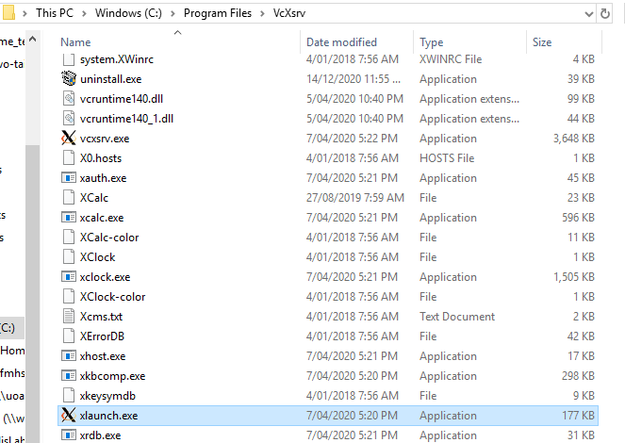

For fsleyes:

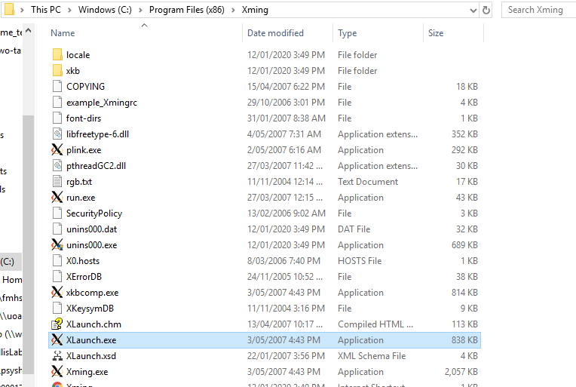

1. I chose to use ICA-AROMA to conduct the single subject denoising from the fMRI data via fmriprep (<https://fmriprep.org/en/stable/workflows.html>). ICA-AROMA is an automatic, non-aggressive denoising technique. *Pruim, R. H. R., Mennes, M., van Rooij, D., Llera, A., Buitelaar, J. K., & Beckmann, C. F. (2015). ICA-AROMA: A robust ICA-based strategy for removing motion artifacts from fMRI data.* There are other options for denoising, such as doing it manually (takes long & might be impossible for large datasets) or using a semi-automatic classifier, such as FSL’s FMRIB’s ICA-based Xnoiseifier (FIX) <https://fsl.fmrib.ox.ac.uk/fsl/fslwiki/FIX>.
2. Note that when performing the denoising ICA-AROMA process, the output space will be MNI152NLinAsym, which is equivalent to FSL MNI152 space. Currently, it cannot be performed in other spaces. The output file will look like this: MNI152NLinAsym_desc-smoothAROMAnonaggr_bold.nii.gz, with the smoothAROMAnonaggr name showing you that the file has been ICA-AROMA denoised. That being said, for each functional bold acquisition, fmriprep provides a corresponding *desc-confounds_timeseries.tsv file, which contains columns of confounds which can be incorporated into your design matrix or denoising procedure – and therefore be able to apply ICA-AROMA to other templates. <https://neurostars.org/t/fmriprep-ica-aroma-output-and-alternative-templates/19773/2>

1. I found that the 5ttgen would most often fail for people who had Alzheimer’s disease (AD). To resolve this, I reoriented the coregistered anatomical files (T1w + T2 FLAIR) to the diffusion file, via fslreorient2std <https://community.mrtrix.org/t/5ttgen-fsl-error-only-0-of-10-structures-were-segmented-successfully/1448/9>. Specifically, this reorients an image to match the orientation of the standard template images (MNI152) so that it can be recognised by FSL for parcellation / segmentation, as described: <https://fsl.fmrib.ox.ac.uk/fsl/fslwiki/Orientation%20Explained>